**ASSIGNMENT-1**

**TICKET BOOKING SYSTEM**

**TASK-1: DATABASE DESIGN**

1. **Create the database named "TicketBookingSystem"**.

Cretae database TicketBookingSystem;

Show databases;

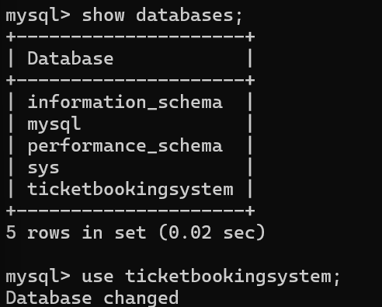

Use TicketBookingSystem;

1. **Write SQL scripts to create the mentioned tables with appropriate data types, constraints, and relationships**.

**Venue**: Create table venue(venue_id integer primary key, venue_name varchar(50), address varchar(100));

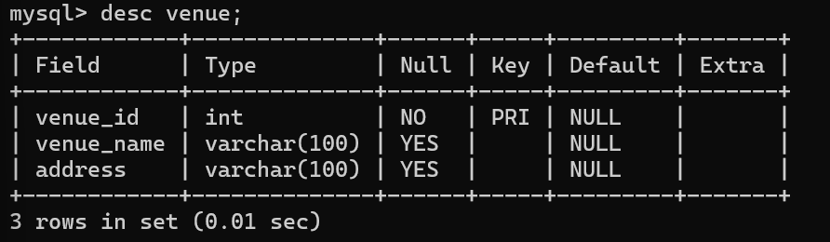

**Event**: Create table event(event_id integer primary key, event_name varchar(100), event_date date, event_time time, venue_id integer, total_seats integer, available_seats integer, ticket_price decimal(10,2), event_type varchar(20), foreign key (venue_id) references venue(venue_id));

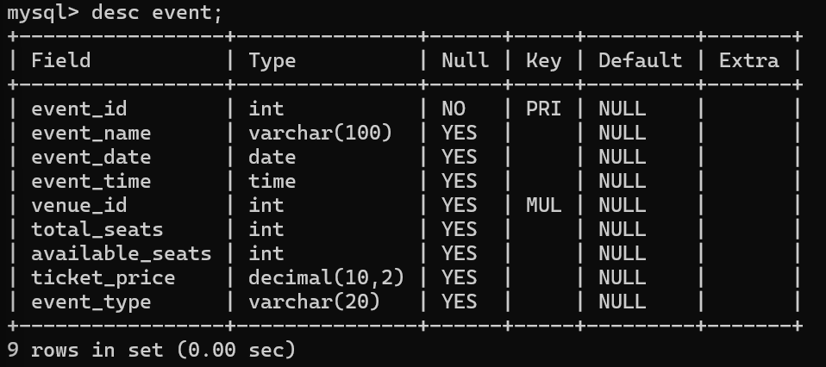

**Customers**: Create table customer(customer_id integer primary key, customer_name varchar(50), email varchar(100), phone_number varchar(10));

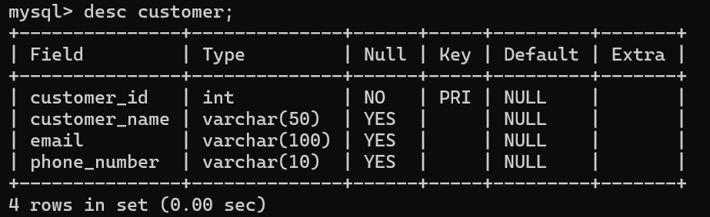

**Booking:** Create table Booking (booking_id integer primary key, customer_id integer, event_id integer, num_tickets integer, total_cost decimal(10, 2), booking_date date, foreign key (customer_id) references Customer(customer_id), foreign key (event_id) references Event(event_id));

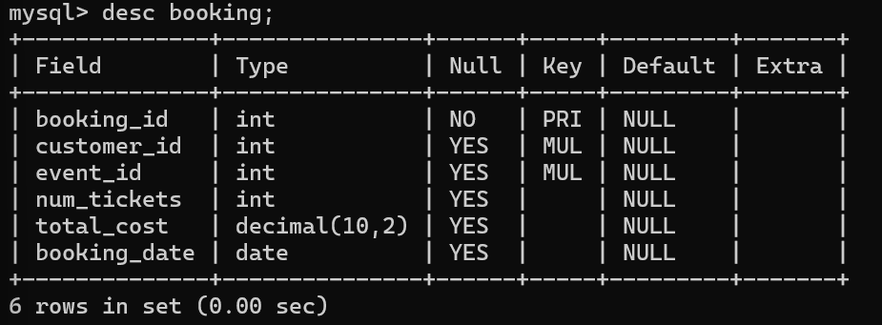

1. **Create an ERD (Entity Relationship Diagram) for the database**.

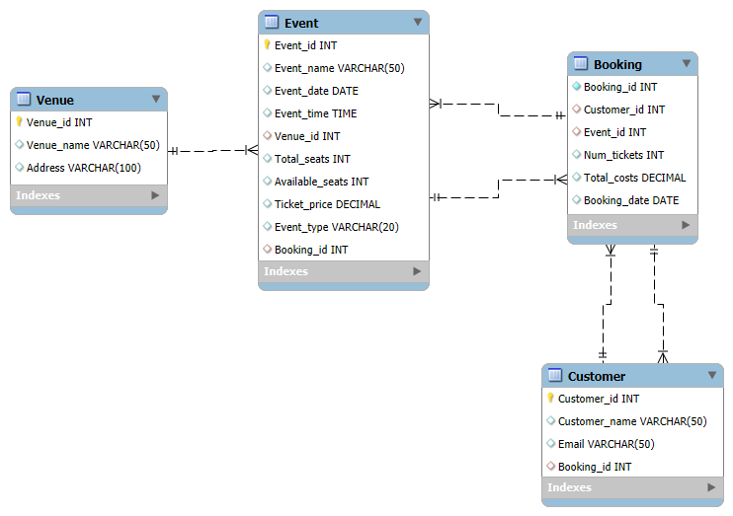

1. **Create appropriate Primary Key and Foreign Key constraints for referential integrity.**

* Alter table event add column booking_id integer, add foreign key (booking_id) references booking(booking_id);

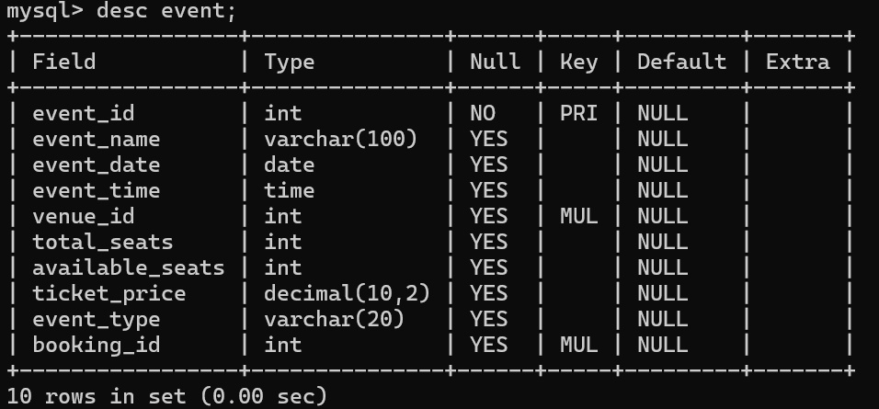

* Alter table customer add column booking_id integer, add foreign key (booking_id) references booking(booking_id);

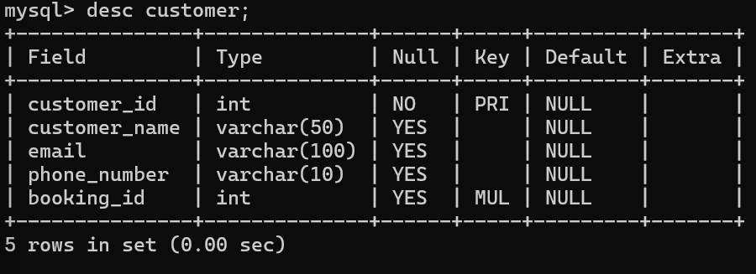

**TASK-2: SELECT, WHERE, BETWEEN, AND, LIKE**

Write a SQL query to insert at least 10 sample records into each table.

**Venue:**

insert into venue values(101,'Royal cinemas','Pallipalayam');

insert into venue values(102,'PVR cinemas','Palayapalayam');

insert into venue values(103,'Cosmos cinemas','Perundurai');

insert into venue values(104,'ABC Ground','Bhavani');

insert into venue values(105,'DEF Ground','Erode');

insert into venue values(106,'GHI Ground','Karur');

insert into venue values(107,'JKL Auditorium','Navalur');

insert into venue values(108,'MNO Auditorium','Shollinganalur');

insert into venue values(109,'PQR Auditorium','Shollinganalur');

insert into venue values(110,'UVW Auditorium','Porur');

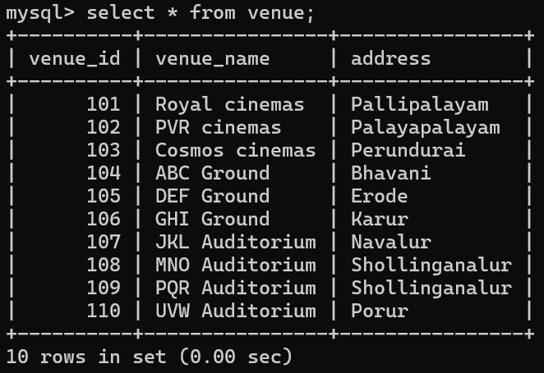

**Event:**

insert into event(event_id, event_name, event_date, event_time, venue_id, total_seats, available_seats, ticket_price, event_type)

values

(1, 'Summer Concert', '2023-08-15', '19:00:00', 101, 10000, 8000, 1500.00, 'Concert'),

(2, 'Fottball Game', '2023-09-23', '15:00:00', 102, 50000, 45000, 50.00, 'Sports'),

(3, 'Movie Premiere', '2023-10-10', '20:00:00', 101, 2000, 1500, 1200.00, 'Movie'),

(4, 'Winter Concert', '2023-12-25', '21:00:00', 103, 5000, 4000, 1000100, 'Concert'),

(5,'Basketball Game', '2024-01-15', '17:00:00', 102, 15000,12000, 75.00, 'Sports'),

(6, 'Play Performance', '2024-02-20', '19:30:00', 11, 1000, 800, 800.00, 'Play'),

(7, 'Rock Concert', '2024-03-30', '20:30:00', 109, 8000, 6000, 1200.00,'Concert'),

(8, 'Tennis Match', '2024-04-10', '14:00:00', 105, 5000, 4500, 100.00, 'Sports'),

(9, 'Musical', '2024-0515', '19:00:00', 107, 2000, 1800, 1000.00, 'Musical'),

(10, 'Comedy Show', '2024-06-20', '20:00:00',103, 1000, 800,500.00, 'Comedy');

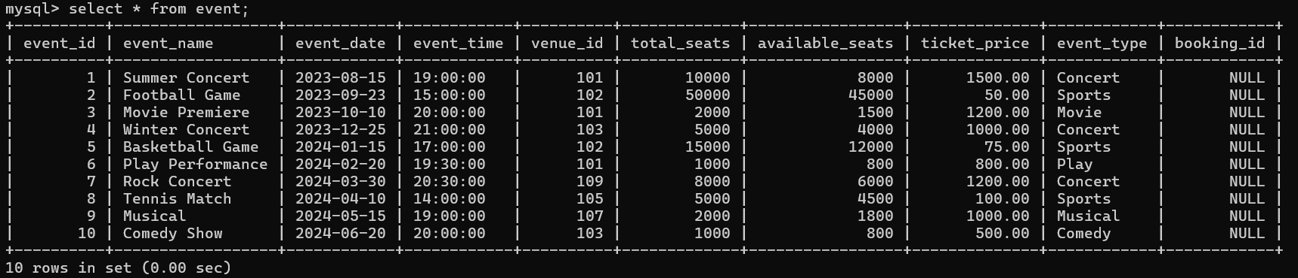

**Customer**:

insert into Customer (customer_id, customer_name, email, phone_number)

values

(1, 'Gayathri', 'gayathri@example.com', '1234567890'),

(2, 'Deepa', 'Deepa@example.com', '9876543210'),

(3, 'Lobi', 'Lobi@example.com', '5555555555'),

(4, 'Moni', 'moni@example.com', '1111111111'),

(5, 'bhusan', 'bhusan@example.com', '2222222222'),

(6, 'harish','harish@example.com', '3333333333'),

(7, 'sandy', 'sandy@example.com', '4444444444'),

(8, 'praveen', 'praveen@example.com', '5555555555'),

(9, 'mei', 'mei@example.com', '6666666666'),

(10, 'deetch', 'deetch@example.com','7777777777');

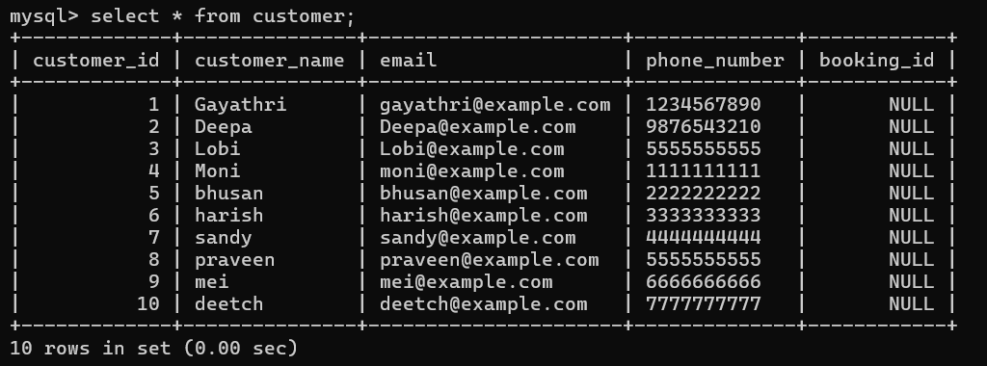

**Booking**:

insert into Booking (booking_id, customer_id, event_id, num_tickets, total_cost, booking_date)

values

(1, 1, 1, 2, 3000.00, '2023-08-10'),

(2, 2, 2, 5, 250.00, '2023-09-18'),

(3, 3, 3, 3, 3600.00, '2023-10-05'),

(4, 4, 4, 4, 4000.00, '2023-12-20'),

(5, 5, 5, 1, 75.00, '2024-01-10'),

(6, 6, 6, 2, 1600.00, '2024-02-15'),

(7, 7, 7, 3, 3600.00, '2024-03-25'),

(8, 8, 8, 5, 500.00, '2024-04-05'),

(9, 9, 9, 4, 4000.00, '2024-05-10'),

(10, 10, 10, 2, 1000.00, '2024-06-15');

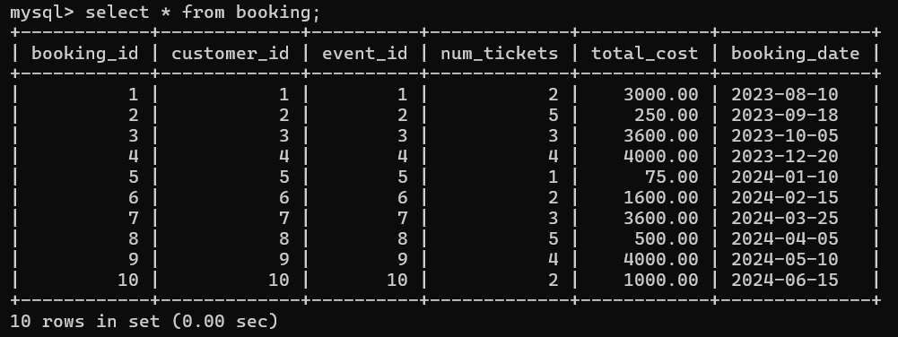

**Updating Booking_id in Event table**:

update event set booking_id=1 where event_id=1;

update event set booking_id=2 where event_id=2;

update event set booking_id=3 where event_id=3;

update event set booking_id=4 where event_id=4;

update event set booking_id=5 where event_id=5;

update event set booking_id=6 where event_id=6;

update event set booking_id=7 where event_id=7;

update event set booking_id=8 where event_id=8;

update event set booking_id=9 where event_id=9;

update event set booking_id=10 where event_id=10;

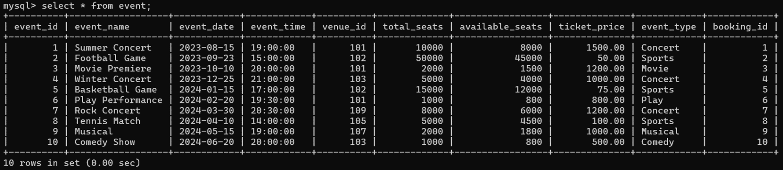

**Updating Booking_id in Customer table**:

update customer set booking_id=10 where customer_id=10;

update customer set booking_id=9 where customer_id=9;

update customer set booking_id=8 where customer_id=8;

update customer set booking_id=7 where customer_id=7;

update customer set booking_id=6 where customer_id=6;

update customer set booking_id=5 where customer_id=5;

update customer set booking_id=4 where customer_id=4;

update customer set booking_id=3 where customer_id=3;

update customer set booking_id=2 where customer_id=2;

update customer set booking_id=1 where customer_id=1;

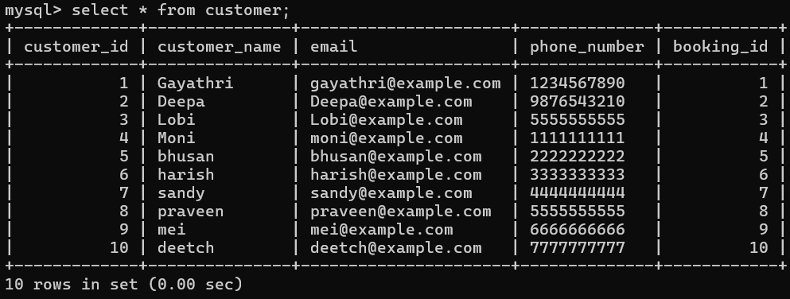

**Write a SQL query to list all Events.**

select event_name from event;

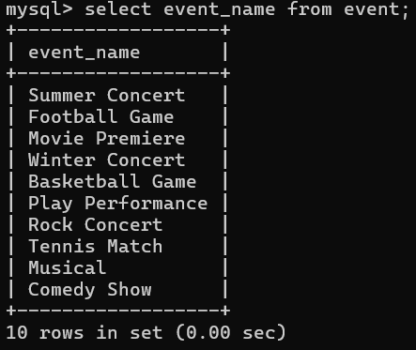

**Write a SQL query to select events with available tickets**.

select * from event where available_seats>0;

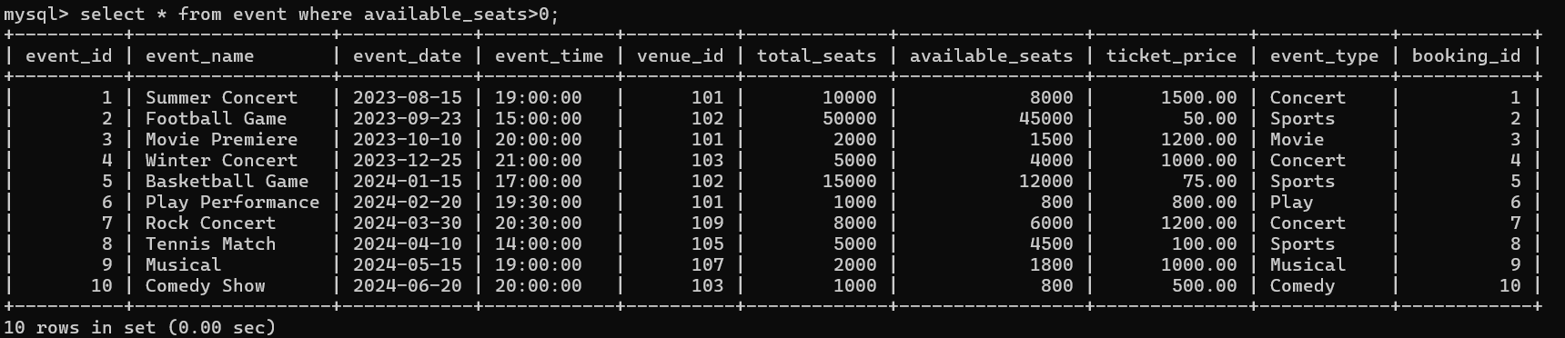

**Write a SQL query to select events name partial match with ‘cup’**.

select * from event where event_name like '%cup%';



**Write a SQL query to select events with ticket price range is between 1000 to 2500**.

select * from event where ticket_price between 1000 and 2500;

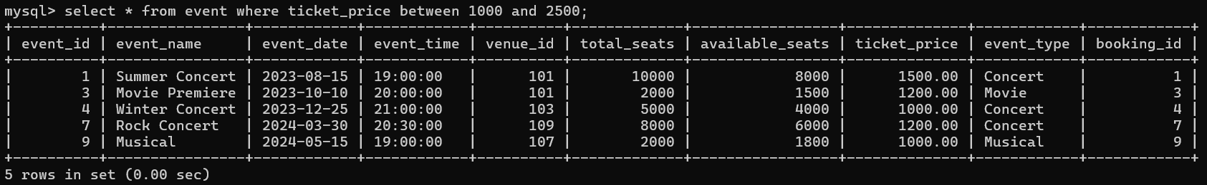

**Write a SQL query to retrieve events with dates falling within a specific range**.

select * from event where event_date between '2023-10-10' and '2024-03-02';

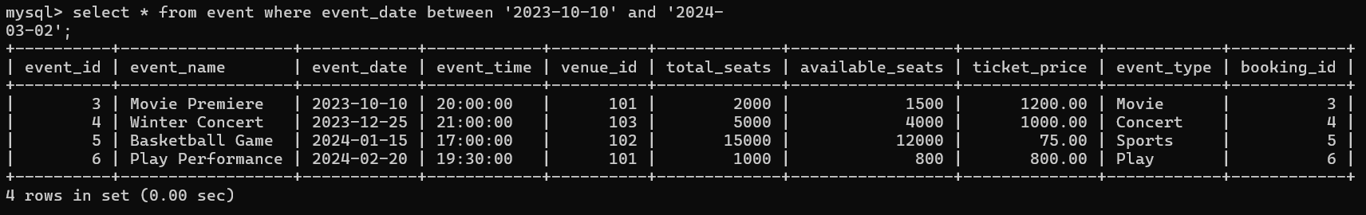

**Write a SQL query to retrieve events with available tickets that also have "Concert" in their name.**

select * from event where available_seats>0 and event_name like '%concert%';

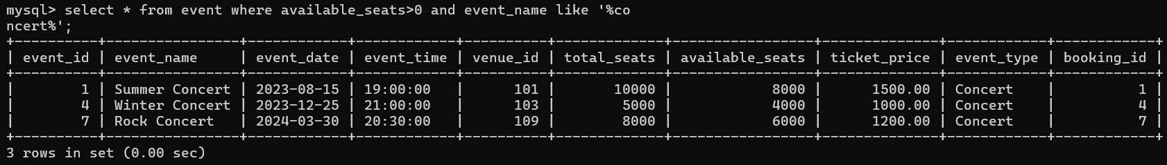

**Write a SQL query to retrieve users in batches of 5, starting from the 6th user.**

select * from customer order by customer_id limit 5 offset 5;

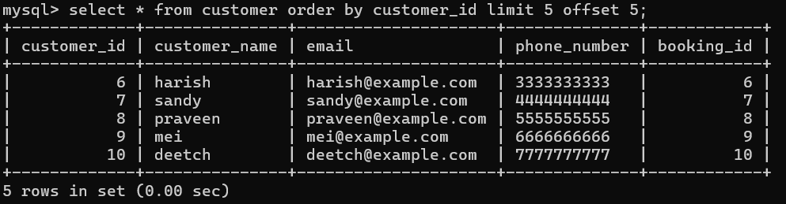

**Write a SQL query to retrieve bookings details contains booked no of ticket more than 4.**

select * from booking where num_tickets>4;

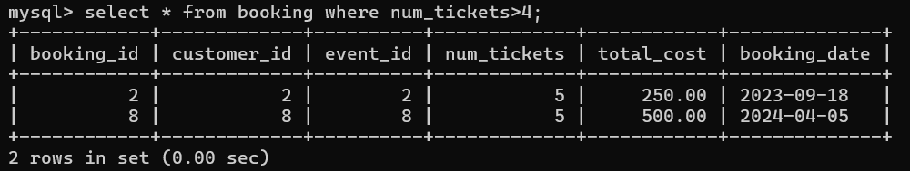

**Write a SQL query to retrieve customer information whose phone number end with ‘000’**

select * from customer where phone_number like '%000';



**Write a SQL query to retrieve the events in order whose seat capacity more than 15000.**

select * from event where total_seats>15000 order by total_seats desc;



**Write a SQL query to select events name not start with ‘x’, ‘y’, ‘z’**:

select * from event where event_name not like 'x%' and event_name not like 'y%' and event_name not like 'z%';

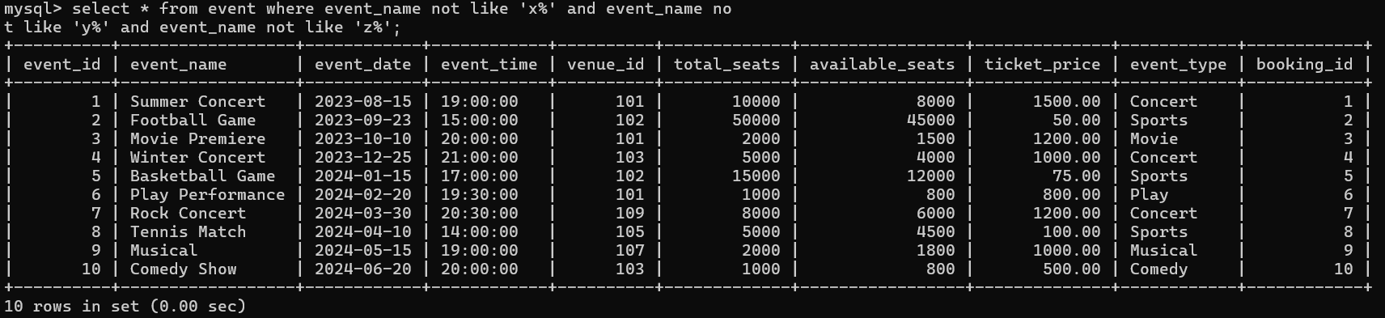

**TASK-3: AGGREGATE FUNCTIONS, HAVING, ORDERBY, GROUPBY AND JOINS**

**Write a SQL query to List Events and Their Average Ticket Prices**

select e.event_name, avg(e.ticket_price) as avg_ticket_price from event e group by e.event_name;

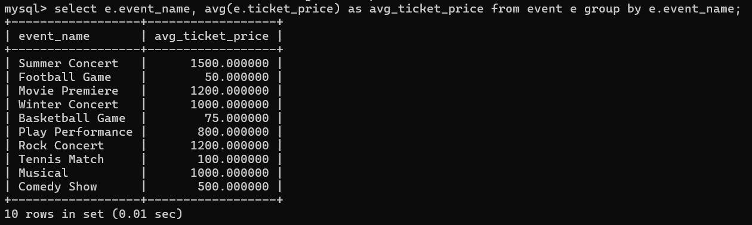

**Write a SQL query to Calculate the Total Revenue Generated by Events.**

select sum(booking.total_cost) as total_revenue from booking;

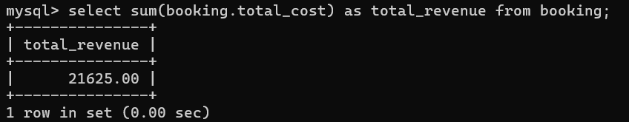

**Write a SQL query to find the event with the highest ticket sales**.

select e.event_name, sum(b.num_tickets) as total_tickets_sold from event e join booking b on e.event_id=b.event_id group by e.event_name order by total_tickets_sold desc limit 1;

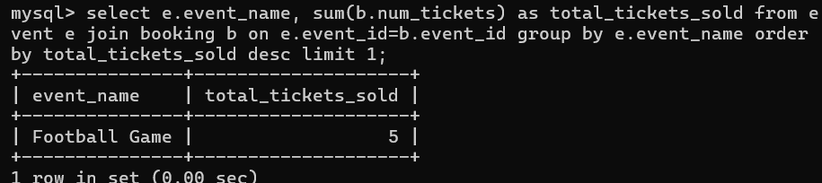

**Write a SQL query to Calculate the Total Number of Tickets Sold for Each Event.**

select e.event_name, sum(b.num_tickets) as total_tickets_sold from event e join booking b on e.event_id=b.event_id group by e.event_name;

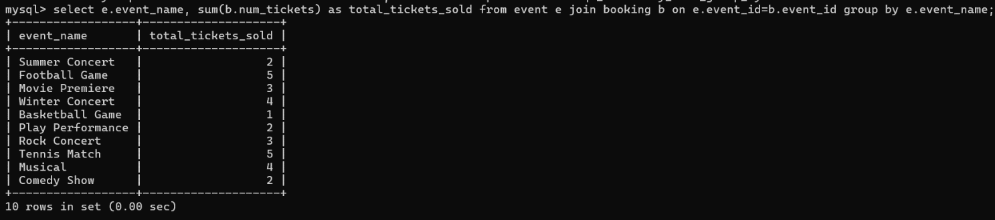

**Write a SQL query to Find Events with No Ticket Sales.**

select e.event_name from event e left join booking b on e.event_id=b.event_id where b.booking_id is null;



**Write a SQL query to Find the User Who Has Booked the Most Tickets**.

select c.customer_name, sum(b.num_tickets) as total_tickets_booked from customer c join booking b on c.customer_id=b.customer_id group by c.customer_name order by total_tickets_booked desc limit 1;



**Write a SQL query to List Events and the total number of tickets sold for each month.**

select e.event_name, month(b.booking_date) as month_num, year(b.booking_date) as year_num, sum(b.num_tickets) as total_tickets_sold from event e join booking b on e.event_id=b.event_id group by e.event_name, month(b.booking_date), year(b.booking_date) order by month_num;

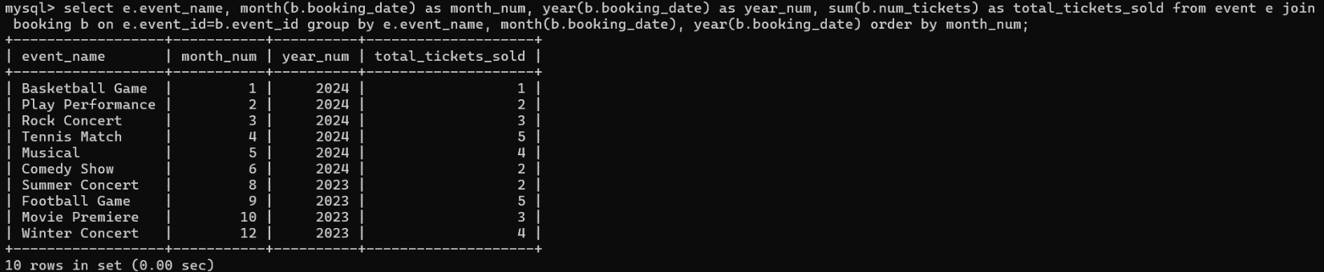

**Write a SQL query to calculate the average Ticket Price for Events in Each Venue**.

select v.venue_name,avg(e.ticket_price) as avg_ticket_price from venue v join event e on v.venue_id=e.venue_id group by v.venue_name;

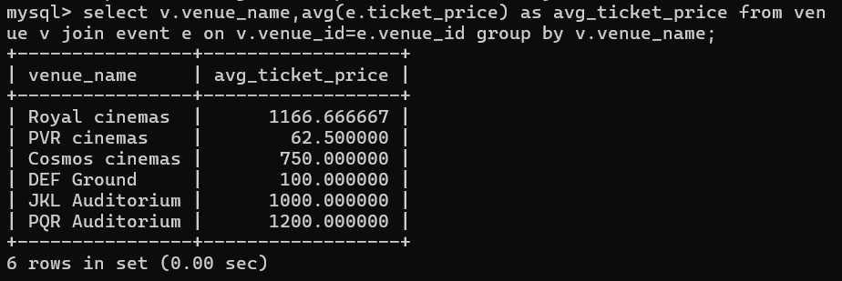

**Write a SQL query to calculate the total Number of Tickets Sold for Each Event Type.**

select e.event_type, sum(b.num_tickets) as total_tickets_sold from event e join booking b on e.event_id=b.event_id group by e.event_type order by total_tickets_sold desc;

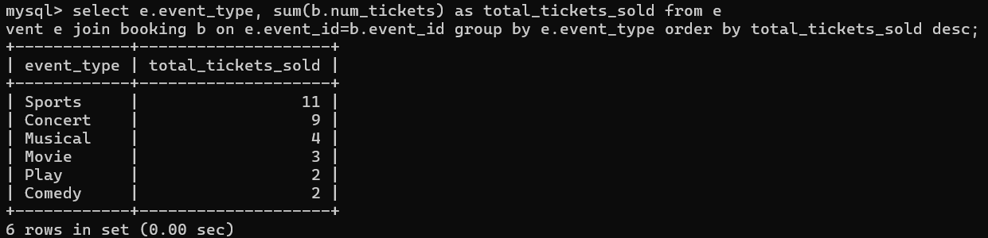

**Write a SQL query to calculate the total Revenue Generated by Events in Each Year**.

select year(b.booking_date) as event_year, sum(b.total_cost) as total_revenue from booking b join event e on b.event_id=e.event_id group by year(b.booking_date) order by event_year;

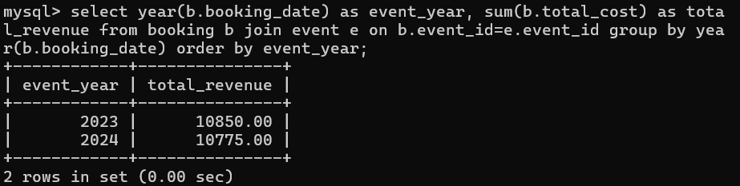

**Write a SQL query to list users who have booked tickets for multiple events**.

select c.customer_name, count(distinct b.event_id) as num_event_booked from customer c join booking b on c.customer_id=b.customer_id group by c.customer_name having count(distinct b.event_id)>1 order by num_event_booked desc;

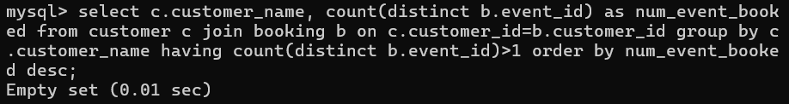

**Write a SQL query to calculate the Total Revenue Generated by Events for Each User.**

select c.customer_name, sum(b.total_cost) as total_revenue from customer c join booking b on c.customer_id=b.customer_id group by c.customer_name order by total_revenue;

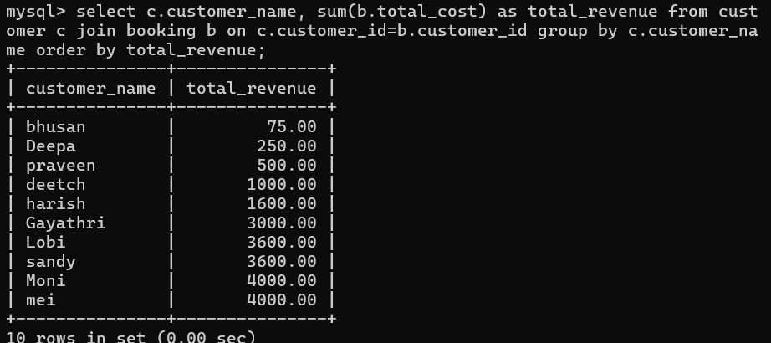

**Write a SQL query to calculate the Average Ticket Price for Events in Each Category and Venue.**

select e.event_type as event_category, v.venue_name, avg(e.ticket_price) as avg_ticket_price from event e join venue v on e.venue_id=v.venue_id group by e.event_type, v.venue_name order by event_category desc;

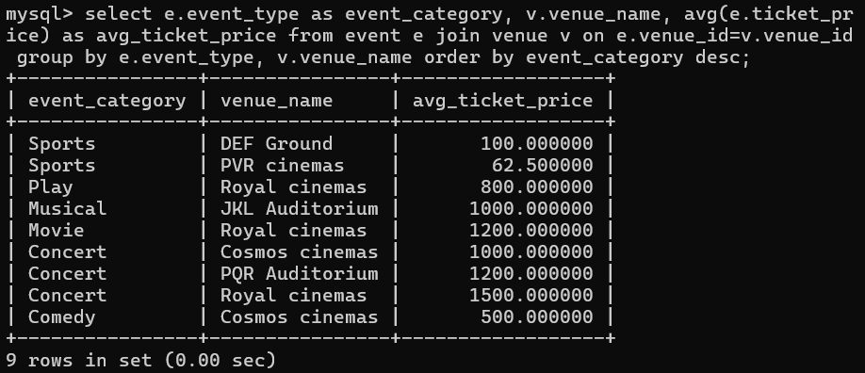

**Write a SQL query to list Users and the Total Number of Tickets They've Purchased in the Last 30 Days.**

select c.customer_name, sum(b.num_tickets) as total_tickets from customer c join booking b on c.customer_id=b.customer_id where b.booking_id>=date_sub(curdate(),interval 30 day) group by c.customer_name order by total_tickets desc;

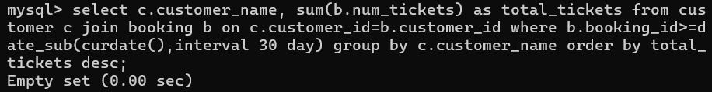

**TASK-4: SUBQUERY AND ITS TYPES**

**Calculate the Average Ticket Price for Events in Each Venue Using a Subquery**.

select v.venue_name,(select avg(ticket_price) from event e where e.venue_id=v.venue_id) as avg_ticket_price from venue v;

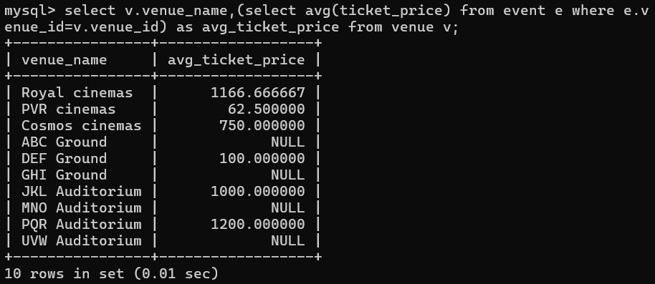

**Find Events with More Than 50% of Tickets Sold using subquery**.

select event_name from event where (select sum(num_tickets) from booking b where b.event_id=event.event_id)>0.5*total_seats;



**Calculate the Total Number of Tickets Sold for Each Event.**

select event_name, (select sum(num_tickets) from booking b where b.event_id=event.event_id) as total_tickets from event;

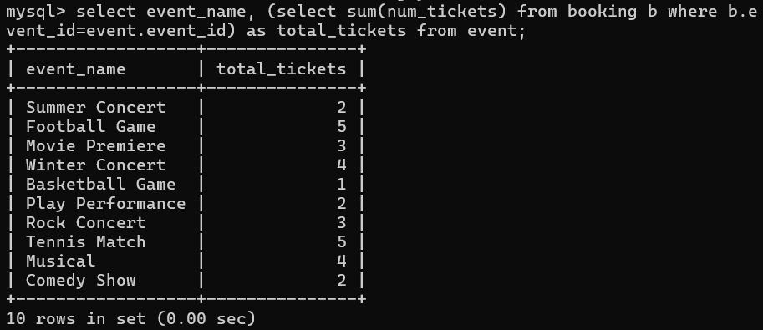

**Find Users Who Have Not Booked Any Tickets Using a NOT EXISTS Subquery**.

select customer_name from customer c where not exists(select 1 from booking b where b.customer_id=c.customer_id);



**List Events with No Ticket Sales Using a NOT IN Subquery**.

select event_name from event where event_id not in (select distinct

event_id from booking);



**Calculate the Total Number of Tickets Sold for Each Event Type Using a Subquery in the FROM Clause**.

select e.event_type from (select event.event_type, sum(booking.num_tickets) as total_tickets from event inner join booking on event.event_id=booking.event_id group by event.event_type) as e;

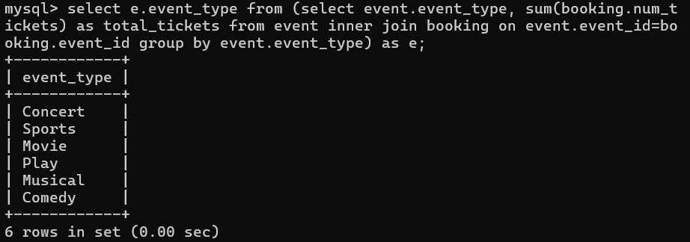

**Find Events with Ticket Prices Higher Than the Average Ticket Price Using a Subquery in the WHERE Clause**.

select event_name from event e where ticket_price>(select avg(ticket_price)from event);

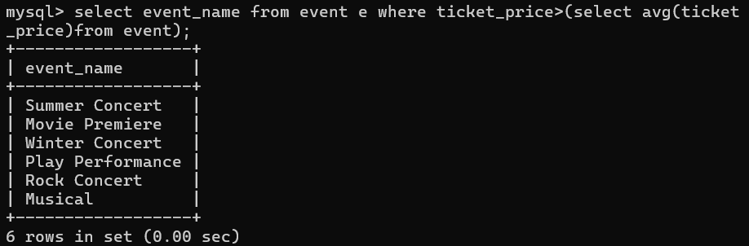

**Calculate the Total Revenue Generated by Events for Each User Using a Correlated Subquery**.

select customer.customer_name,(select sum(booking.total_cost) from booking where booking.customer_id=customer.customer_id)as total_revenue from customer;

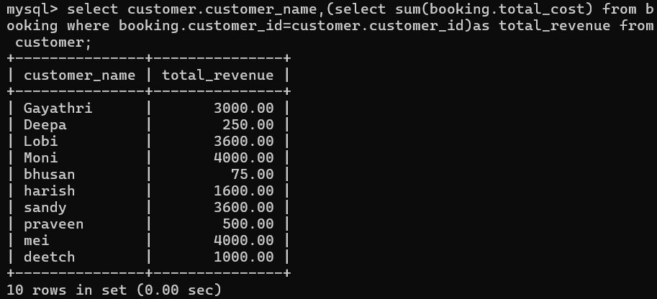

**List Users Who Have Booked Tickets for Events in a Given Venue Using a Subquery in the WHERE Clause**.

select customer_name from customer where customer_id in(select distinct b.customer_id from booking b join event e on b.event_id=e.event_id where e.venue_id=103);

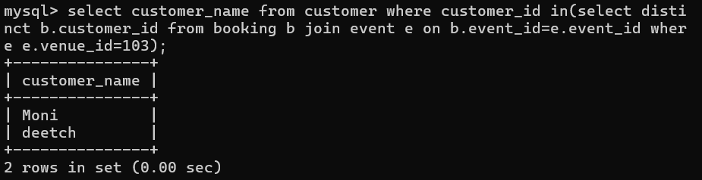

**Calculate the Total Number of Tickets Sold for Each Event Category Using a Subquery with GROUP BY**.

select event_type, sum(total_ticket) as total_ticket from (select e.event_id, e.event_type, coalesce(sum(b.num_tickets),0) as total_ticket from event e left join booking b on e.event_id=b.event_id group by e.event_id,event_type) as sub group by event_type;

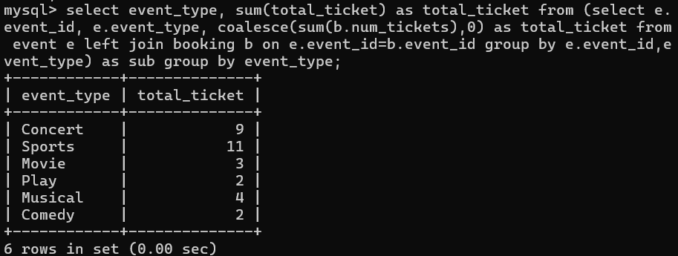

**Find Users Who Have Booked Tickets for Events in each Month Using a Subquery with DATE_FORMAT**.

select customer_name, date_format(booking_date, '%y-%m') as booking_month from customer c join booking b on c.customer_id=b.customer_id group by customer_name, booking_month;

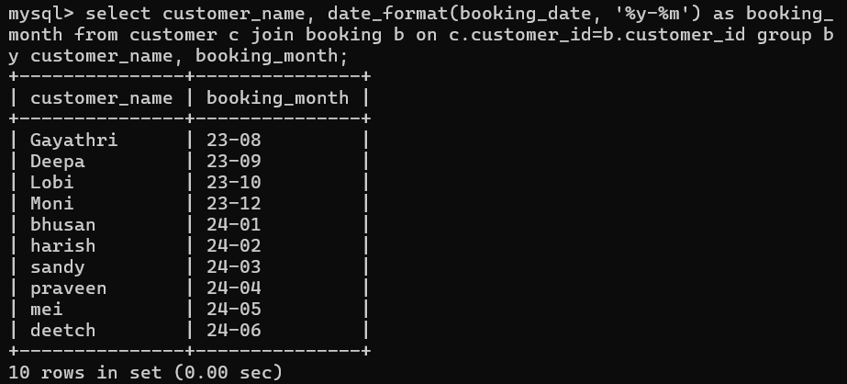

**Calculate the Average Ticket Price for Events in Each Venue Using a Subquery**

select v.venue_name, (select avg(ticket_price) from event e where e.venue_id=v.venue_id) as avg_ticket_price from venue v;

